ScoutScale Users Guide

Table of Contents

Description 2

ScoutScale Hardware Components 2

ScoutScale Software Packages 3

Setup 4

Additional Setup Help 9

Starting the ScoutScale 9

Usage 10

Tare 10

Calibration 11

Capture 13

Side Menu 15

Settings 15

Checklist 17

QR Code 17

Delete Previous Entry 18

Debugging Mode 18

Exit Program 21

Common Issues and Potential Solutions 22

Arduino Board Not Functioning Correctly 22

Serial Errors When Attempting to Launch 23

Program Window too Large to View 23

# Description

This user’s manual details the operation of the ScoutScale desktop application to use the scale hardware and firmware to measure weight values of items placed on any ordinary table. The main sections detailed in this report are:

* ScoutScale Hardware Components
  + This section details all hardware required for ScoutScale’s operation.
* ScoutScale Software Components
  + This section details all software required for ScoutScale’s operation.
* Setup
  + This section details the hardware setup for ScoutScale and initial software configuration to run the ScoutScale desktop application.
* Usage
  + This section serves as a how to guide for the ScoutScale desktop application, with instructions and documentation on how to use the application.
* Common Issues and Potential Solutions
  + This section details some commonly encountered issues and their potential problem solutions for the setup and operation of ScoutScale.

# ScoutScale Hardware Components

These are the components required for the operation of ScoutScale.

1 – Standard folding table

4 – ScoutScale Load Legs

1 – ScoutScale Hub

1 – Desktop/Laptop Computer

* Capable of running python and being located at the weighing site.

4 – Ethernet Cables

* Capable of reaching the ScoutScale Hub from each of the load legs.

1 – USB-A to USB-B Cable

# ScoutScale Software Packages

Where Software is Stored

GitHub Repository:

* <https://github.com/tsallwasser/ScoutScale/tree/master>

Where Captured Data is Stored

Firebase Database:

* <https://console.firebase.google.com/u/1/project/scout-scale-1/firestore/databases/-default-/data/~2FScale%20App~2F1e8r22QXS18kOCNFAcR5>

Software Needed for Operation of ScoutScale Scale Hardware

* Firmware Sketch
  + Uploaded to Arduino to read values provided by load legs and communicate data to the ScoutScale desktop application.
* ScoutScale desktop application
  + Runs on any local desktop and allows the user to operate the scale hardware and firmware to capture weight values.
* All software needed for desktop operation is located in the scale_software directory of the ScoutScale GitHub.

# Setup

Step 1: Place foam inserts in the bottom of the load leg to prevent leg misalignment.

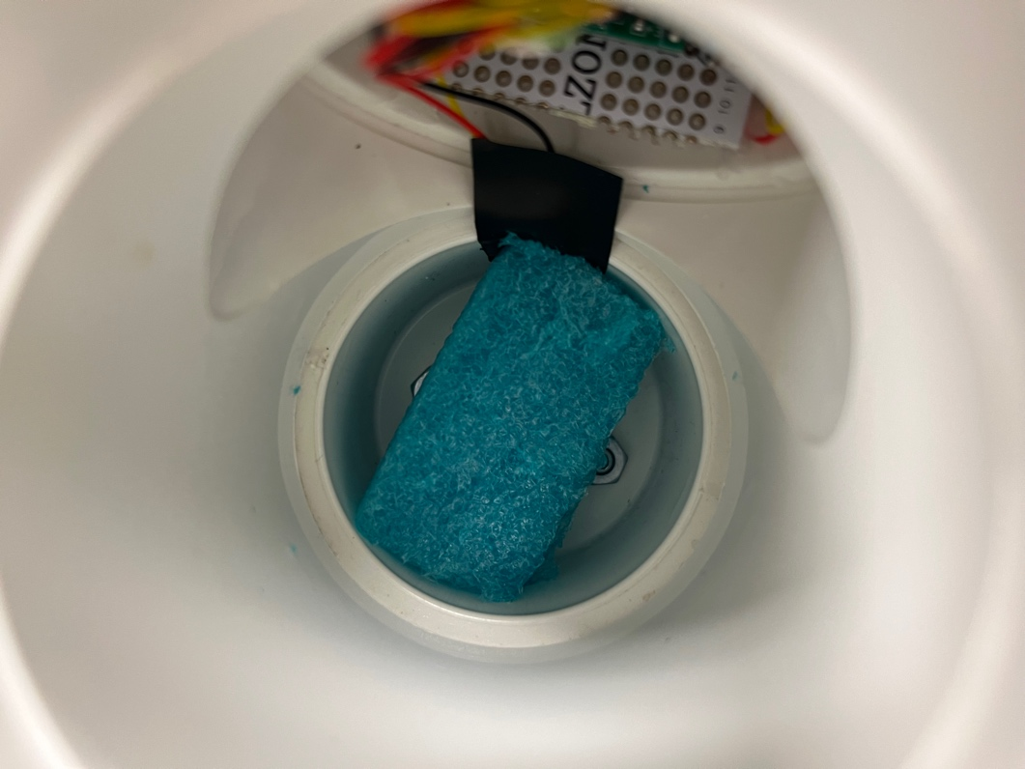

Step 2: Collect Load Leg and foam casing to place on table leg.

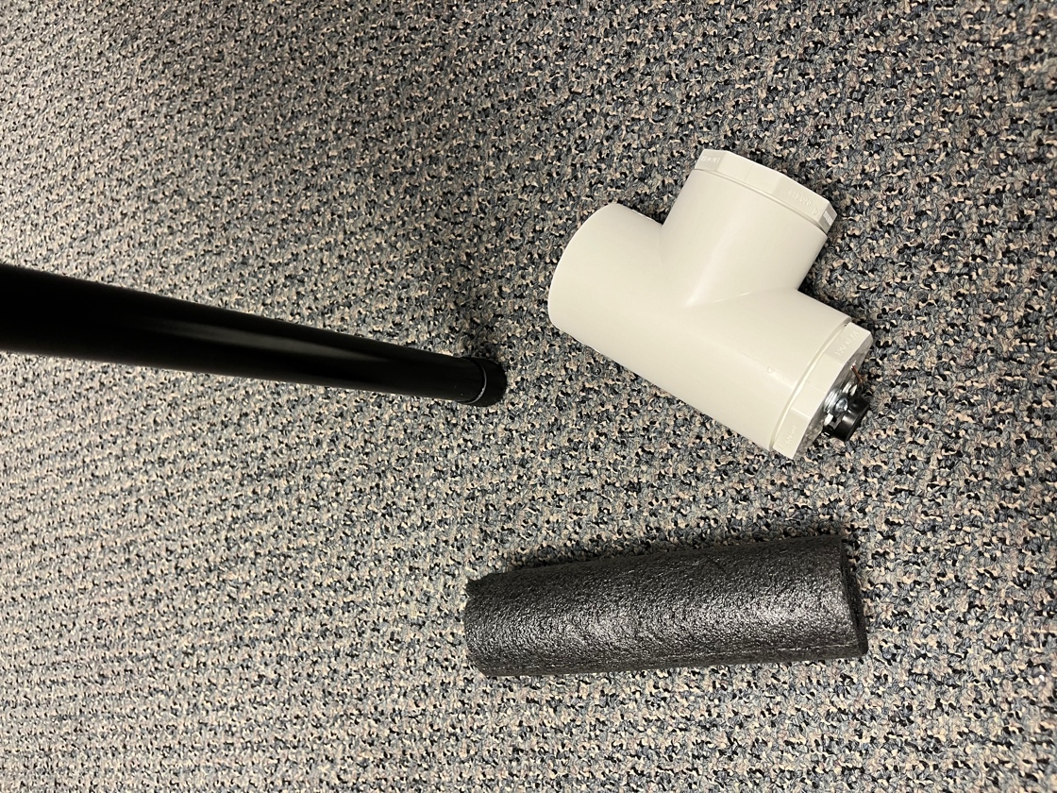

Step 3: Place Load Leg and foam casing on table leg.

* Use smaller pieces of foam, like the blue section shown in the image below, to ensure a tight fitting and vertical alignment.

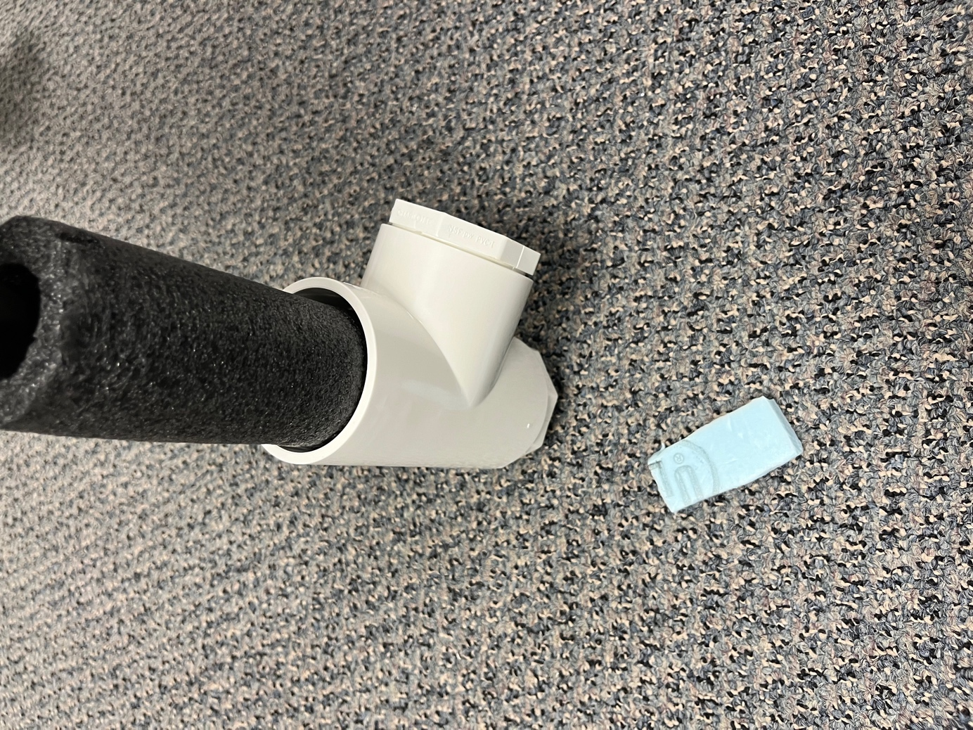

Step 4: Ensure that the foot of the load leg is the only part touching the ground.

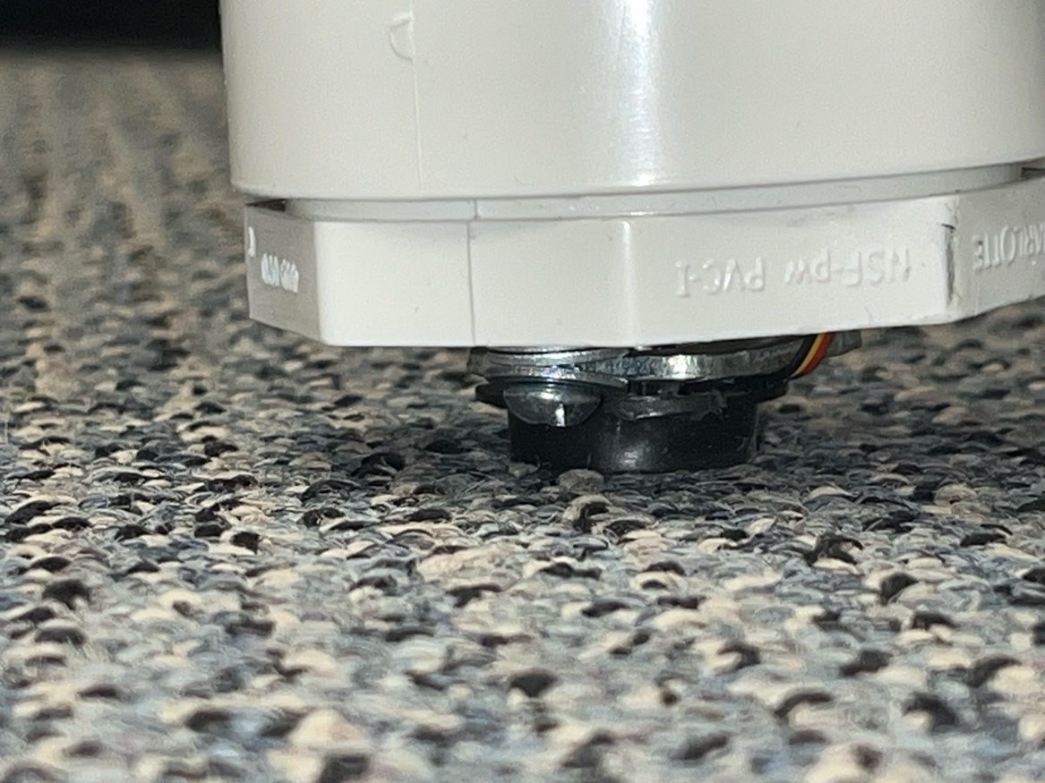

Step 5: Plug an ethernet cable into the load leg.

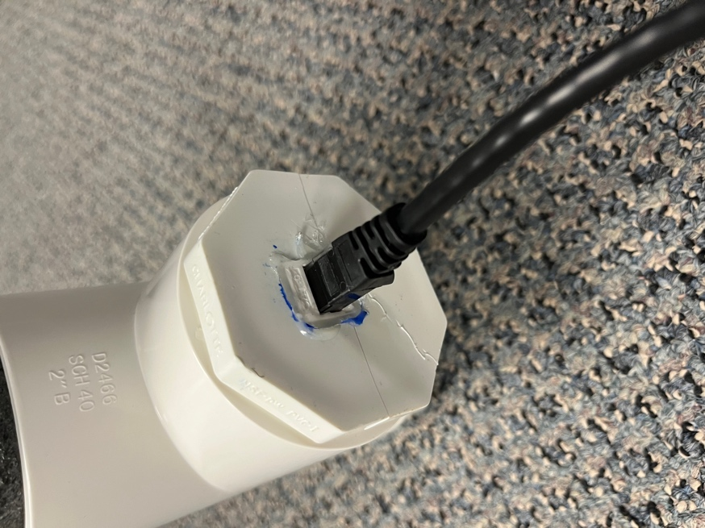

Step 6: Plug that same ethernet cable connected to the load leg into the scale hub.

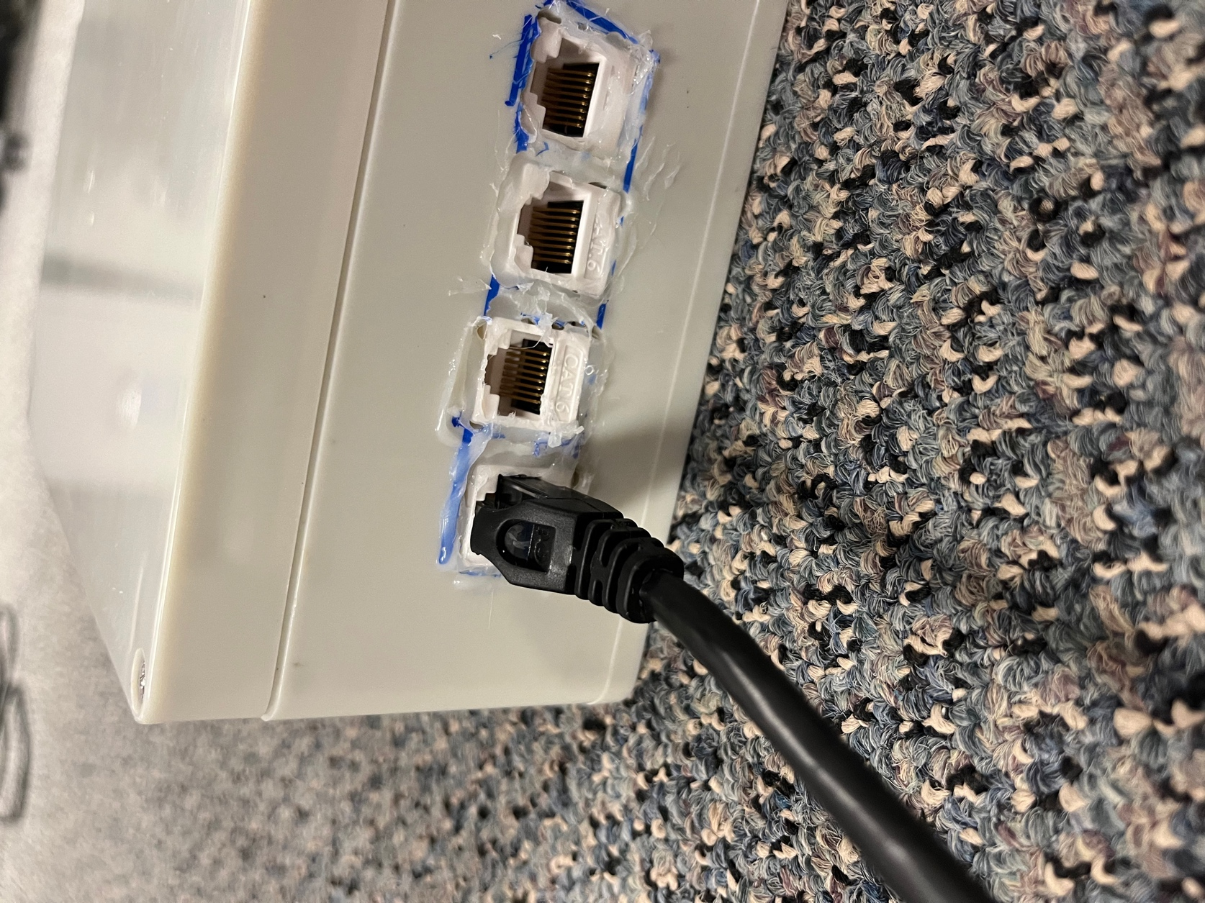

Step 7: Repeat steps 1-6 for the three other table legs.

Step 8: Connect the scale hub to the PC running the ScoutScale desktop application using the USB A-B cable.

* The light on the side of the scale hub should turn on to establish a connection that has been made.

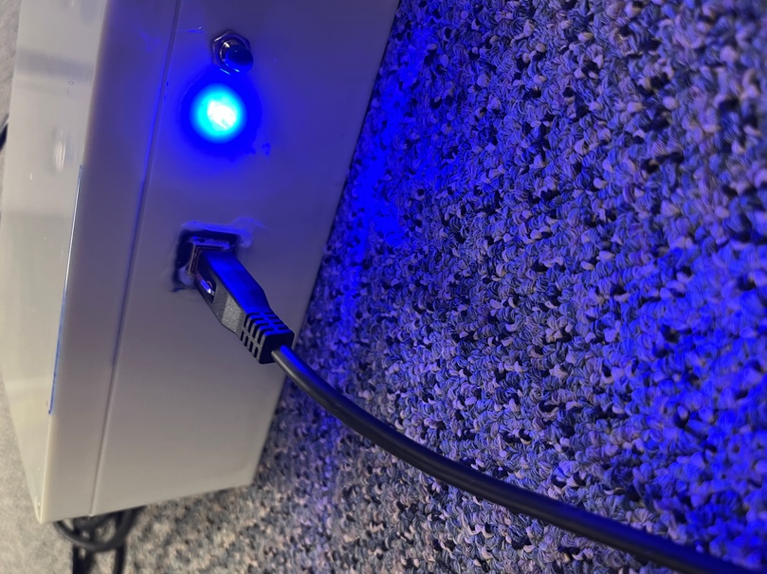

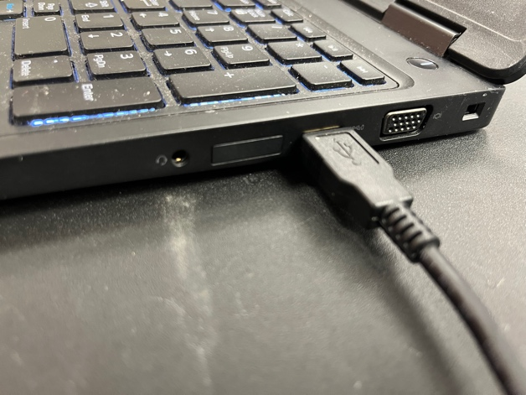

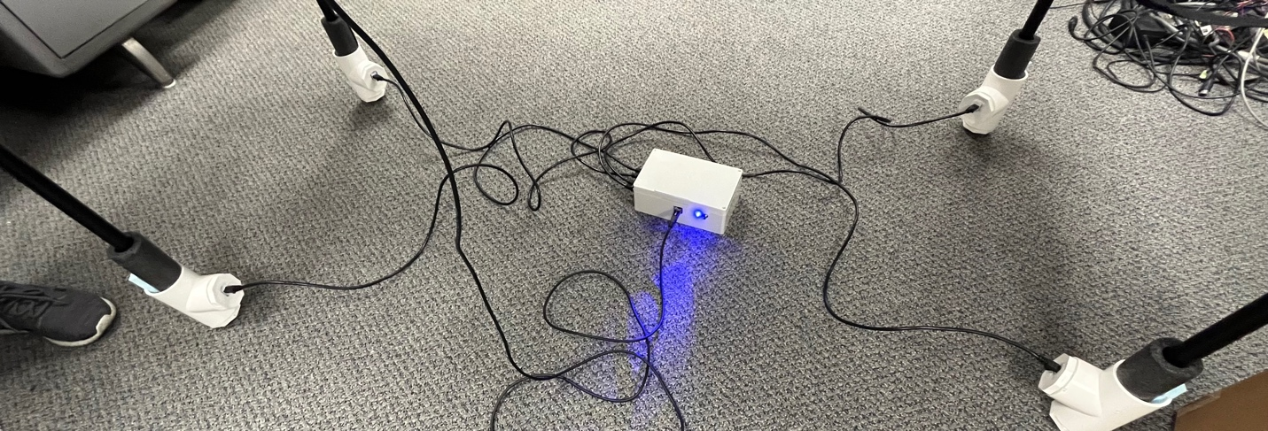

Step 9: Run the ScoutScale desktop application using the appropriate script for your operating system.

* View the additional setup help section for more detail.

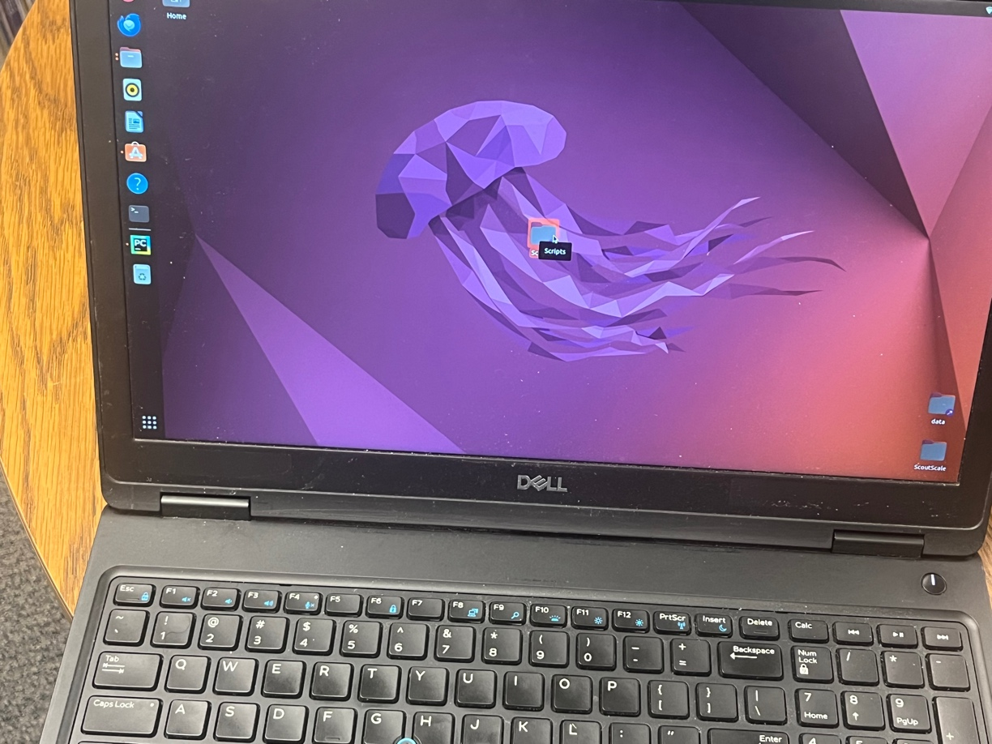

Setup Complete, refer to the usage section of this manual for additional detail on how to use the ScoutScale desktop application.

## Additional Setup Help

### Starting the ScoutScale

To start the ScoutScale desktop application there are three different sets of scripts for different operating systems: Windows, Linux, and macOS. Within each of these files there are two scripts and a usage markdown file. The usage markdown file contains the explicit steps and commands needed to run the two scripts for the desktop application.

# Usage

## Tare

To ensure that the measuring of the food items is as accurate as possible a tare operation was added to the ScoutScale application. The tare button zeroes out the scale to compensate for the weight of the table. It is recommended, but not necessary, to tare the table before each measurement. The tare operation will only take a few seconds. Steps outlined below.

Step 1: Select the tare scale button.

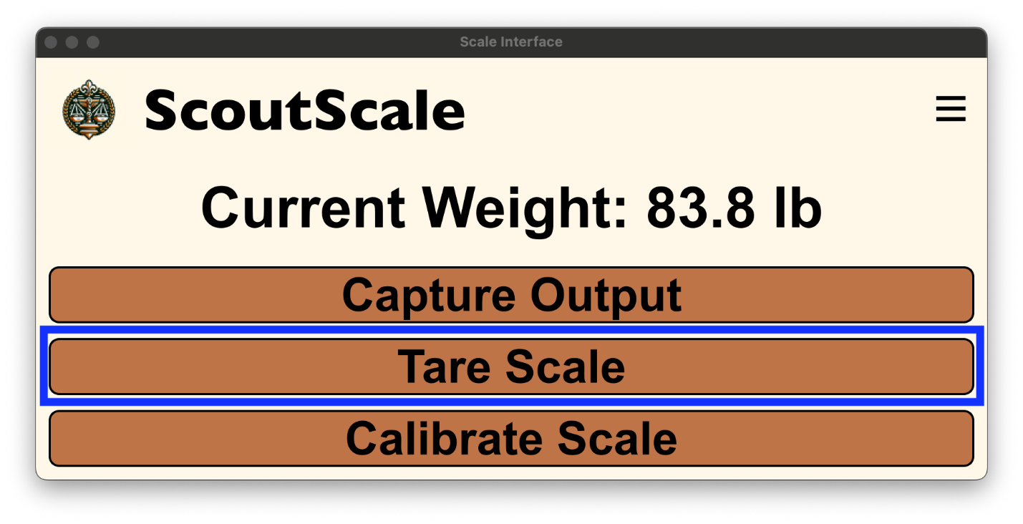

Step 2: Wait for the tare to be completed.

* This is a blocking operation and the ScoutScale application will be inoperable until the tare is complete. This ensures that all four load legs will complete their individual tare operations.
* Once the pop-up window disappears the tare operation is complete.

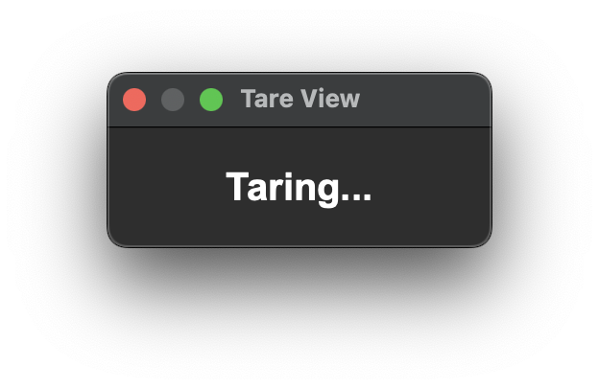

## Calibration

For the scale to output accurate weight values a calibration procedure needs to be run at startup and if measuring units are changed. The steps for running a calibration procedure are outlined below.

Step 1: Select the calibrate scale button.

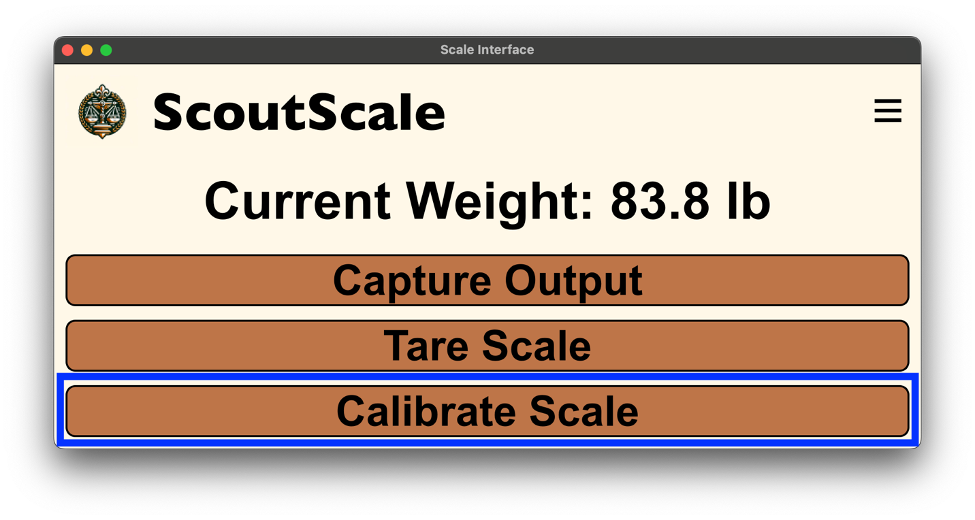

Step 2: Follow the prompt directions.

* This allows the scale to Tare and ignore the weight of the table.

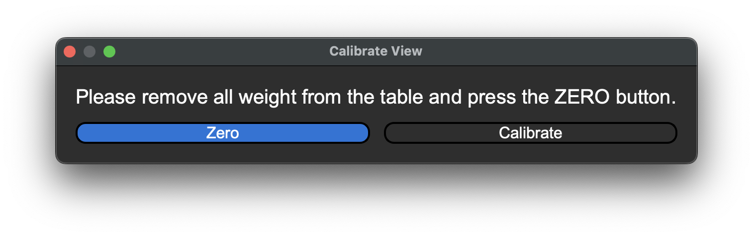

Step 3: Wait for tare completion.



Step 4: Follow the prompt directions.

* It is important to note that the known calibration weight value needs to be placed onto the scale before the CALIBRATE button is pressed. This is because the known weight is captured upon the press of the CALIBRATE button.
* NOTE: There may be a slight delay upon the completion of step 4 and the start of step 5 as there is a built in five second weight for the table to settle.

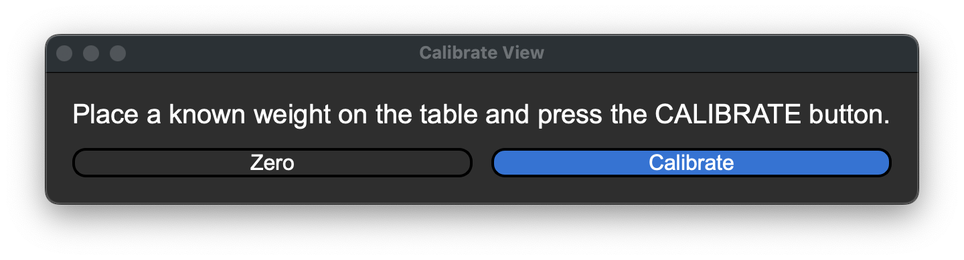

Step 5: Follow prompt directions.

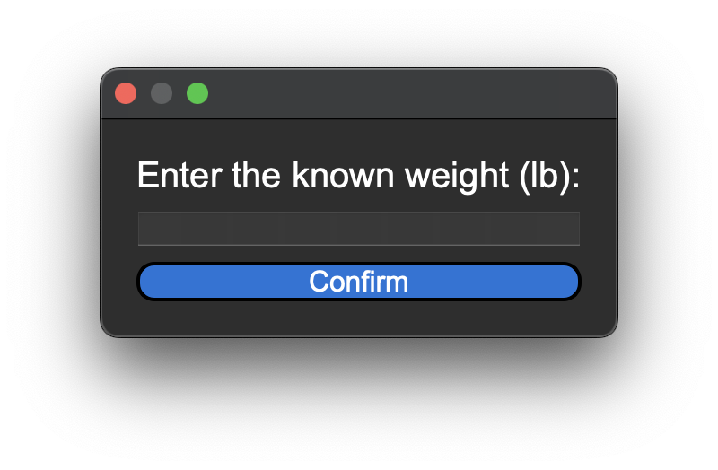

Step 6: Calibration is complete.

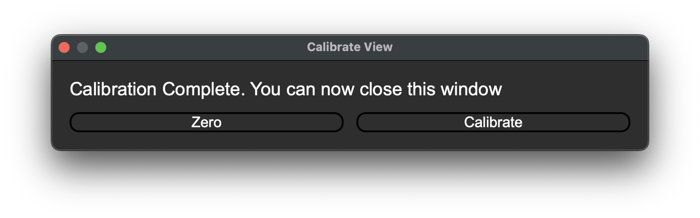

Note: If calibration is aborted the changes will not take effect.

* If the user cancels calibration, either by closing the calibrate view window or known calibration weight window, the calibration procedure will not take effect and the previous calibration value will still be used.

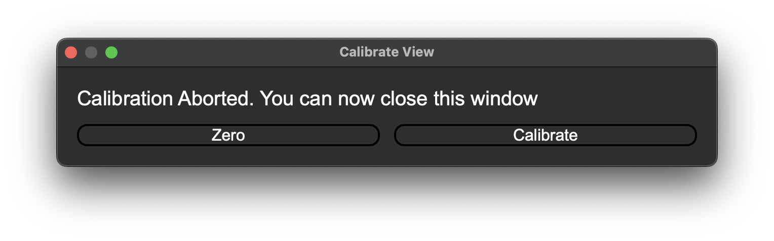

## Capture

The capture functionality is needed to record the weight placed on the table. Steps to capture weight values shown below.

Step 1: Select the capture output button.

* Note that the weight value is captured when this button is pressed, not later in the operation.

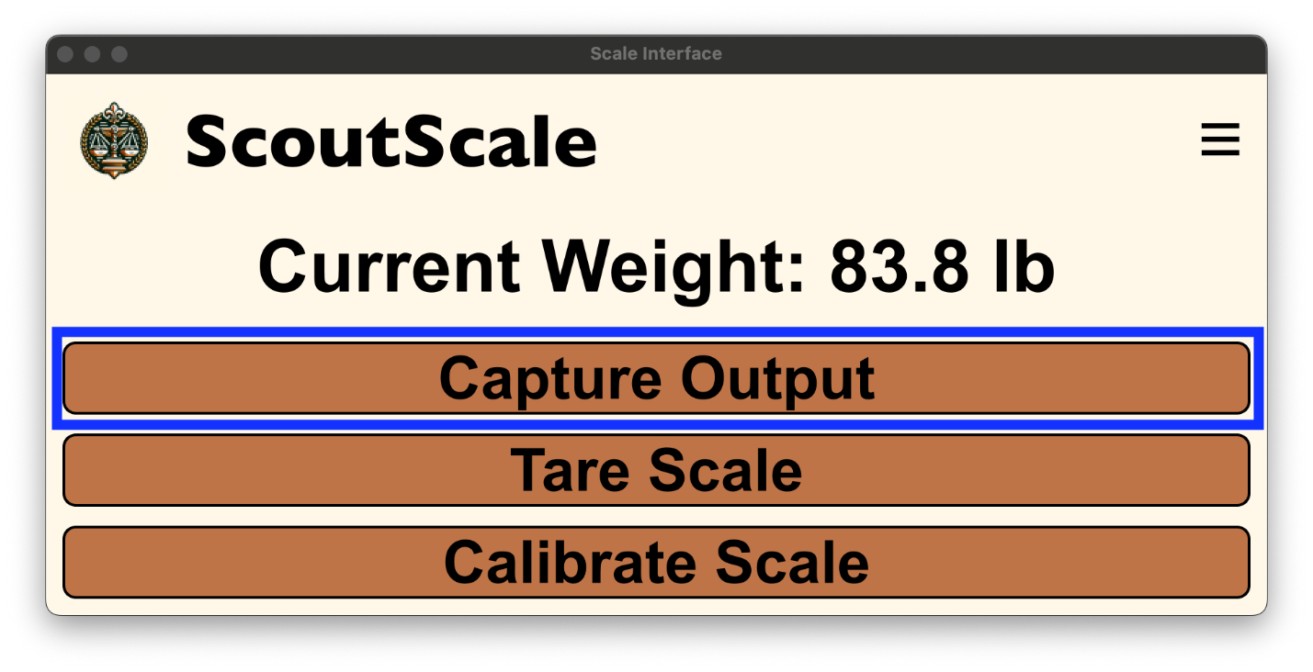

Step 2: Enter the corresponding zone value for the weight.

* The captured weight dialog allows for visual verification that the captured weight looks correct. This will be the value uploaded to the database and captured in the local .csv file.

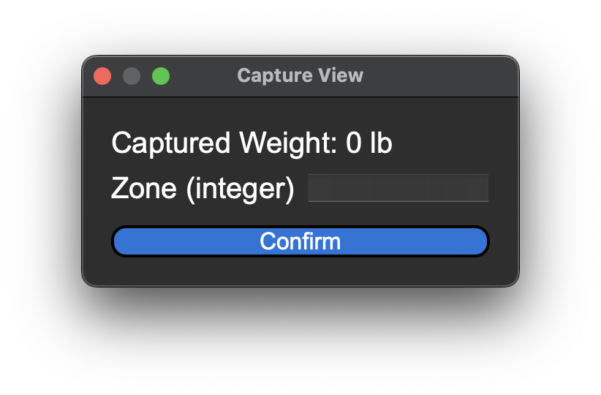

Note: If the zone is not an integer input the capture will be discarded.

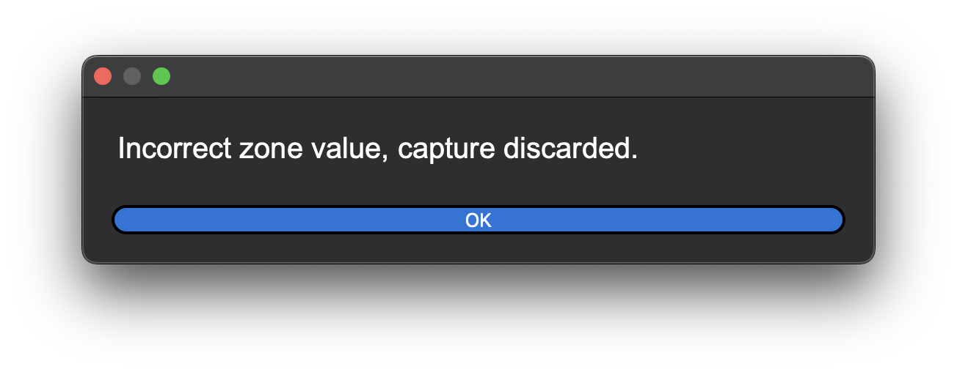

Note: If a weight value of 0 is captured, it will be discarded.

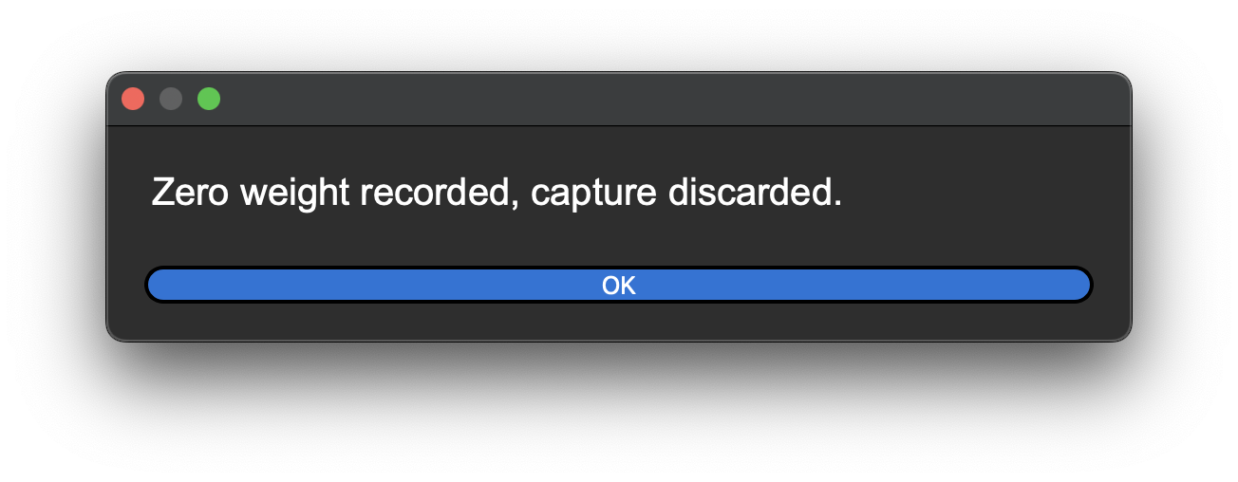

## Side Menu

The side menu contains many other features useful to the operation of ScoutScale. To access the side menu, select the hamburger menu button and the side menu will extend out of the application window.

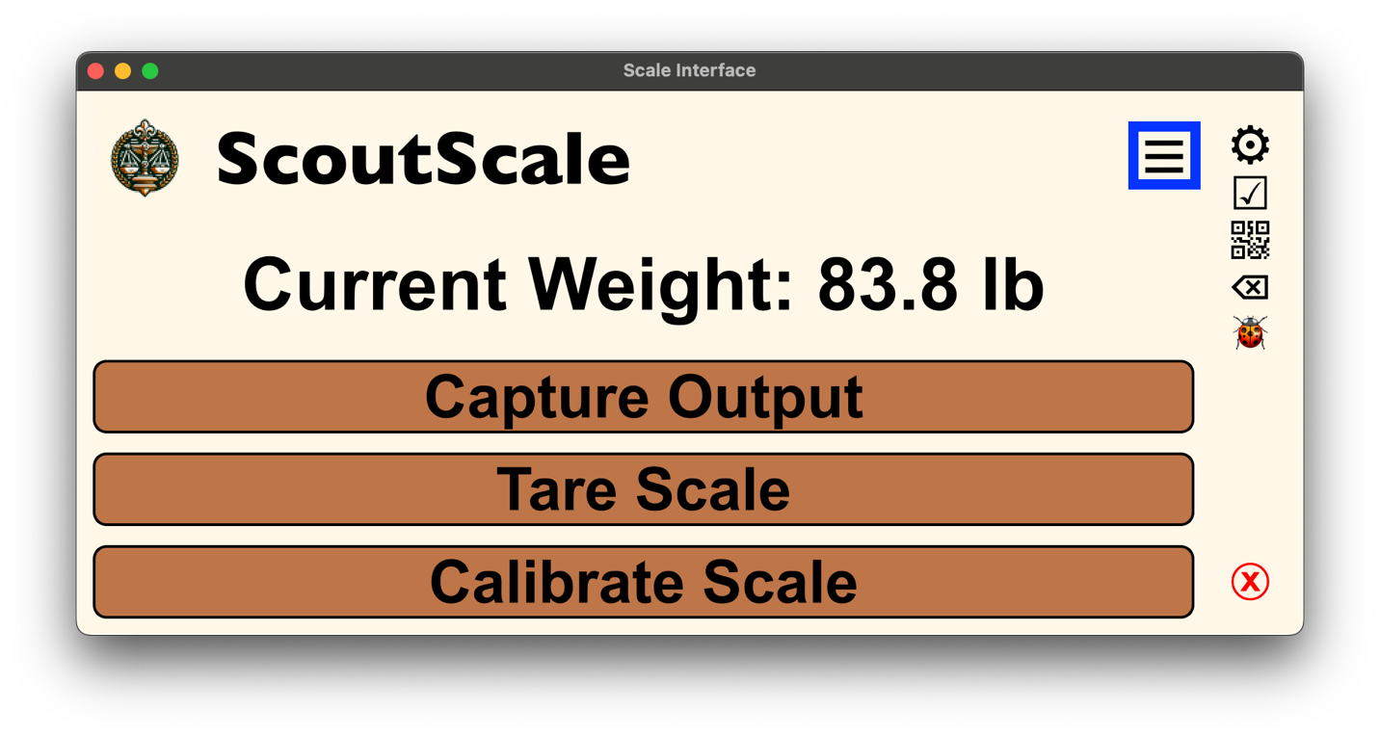

The buttons contained within the side menu are covered in the sections below.

### Settings

Icon:  ⚙

Purpose:

The settings button allows the user to access the configuration parameters for the ScoutScale application. Once the Settings button is pressed the following menu appears.

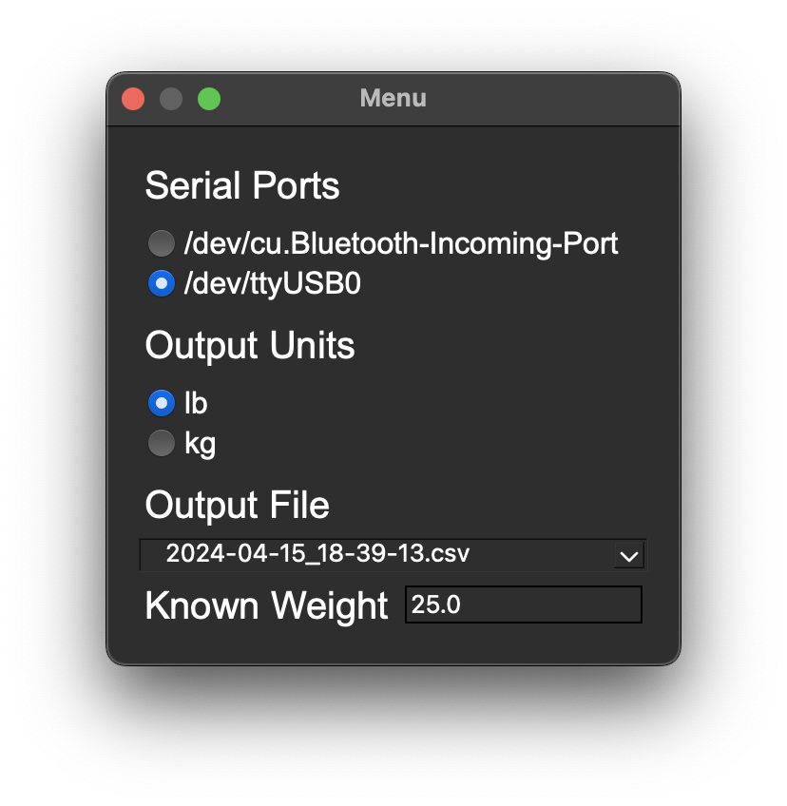

Settings Menu Sections

Serial Ports:

* The serial ports section lists out all connected serial ports for your device. The selection is a radio button format where the ScoutScale application will communicate through the selected serial port. This is how the ScoutScale desktop application establishes communication with the scale hub.
* The best way to determine which port is the scale hub is to compare the member serial ports before and after connecting the scale hub to the device running the ScoutScale desktop application.
* NOTE: device “/dev/ttyUSB0” is a mock port used to inform the user that the correct serial device needs to be selected.

Output Units:

* The output unit's selection lists out the supported unit types for the ScoutScale application. This section also uses a radio button format, where the selected unit will be attached to both the local capture and database upload.
* NOTE: A calibration procedure must be performed after the output units are changed as internal conversion of values is not supported.

Output File:

* This allows the user to select which local .csv file they would like results to be captured in. When the output file field is selected a scrolling menu of all. csv’s located in the application’s data folder are populated and the user can select any file by clicking on the entry.
* NOTE: The file shown in the settings window is the current output file

Known Weight:

* This field allows the user to enter a known weight value to be used for table debugging. More detail about the usage of this value is covered in the Debugging section of the side menu section.

### Checklist

Icon:  ☑

Purpose:

The checklist button allows the user to toggle the visibility of the startup checklist of the ScoutScale desktop application. Current checklist shown below.

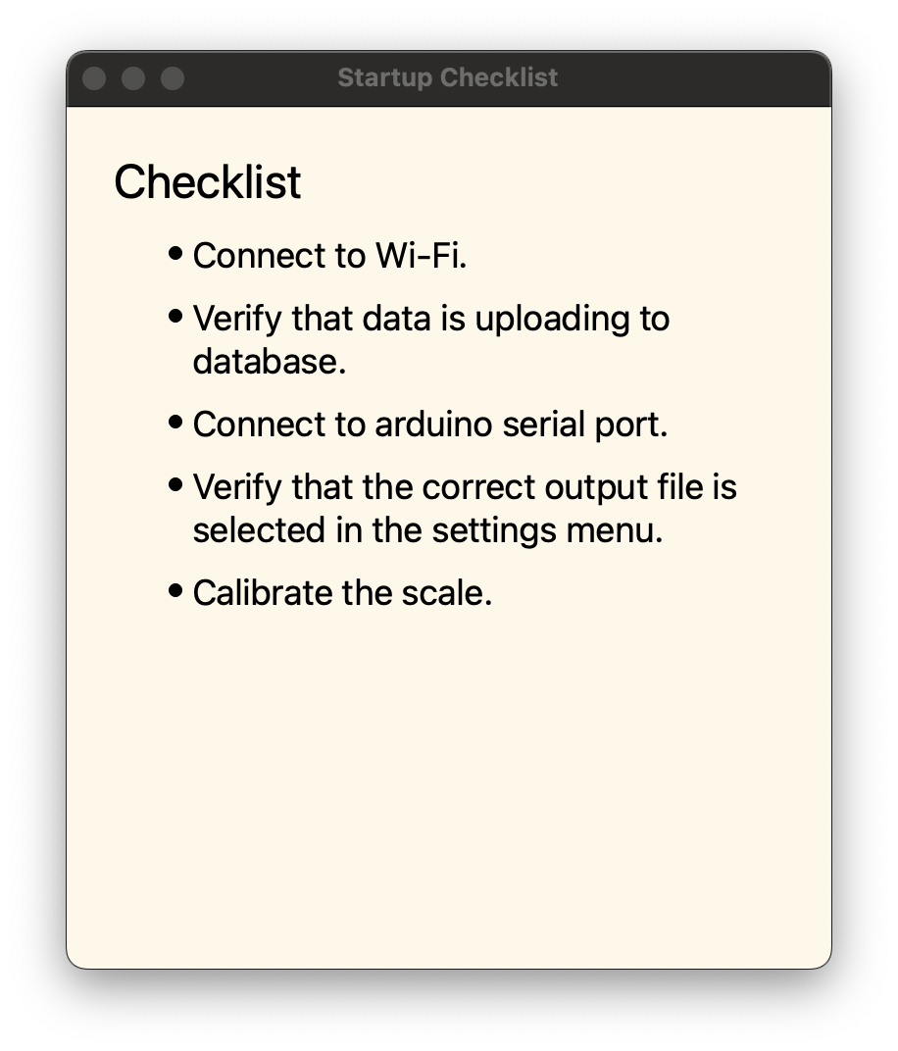

### QR Code

Icon:  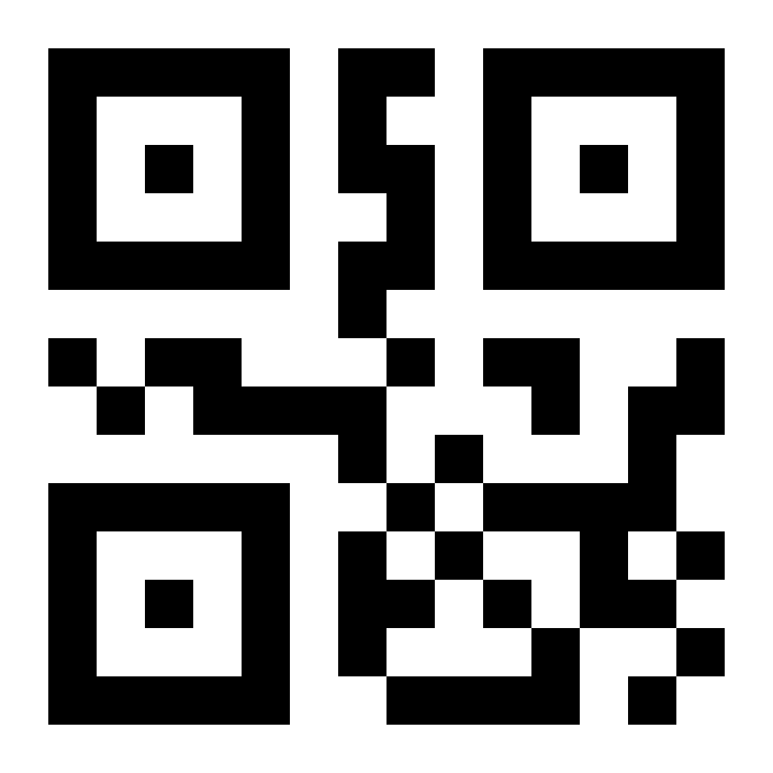

Purpose:

The QR Code button allows the user to toggle a view to show a QR code link to the ScoutScale Web application. Image of the QR Code window below.

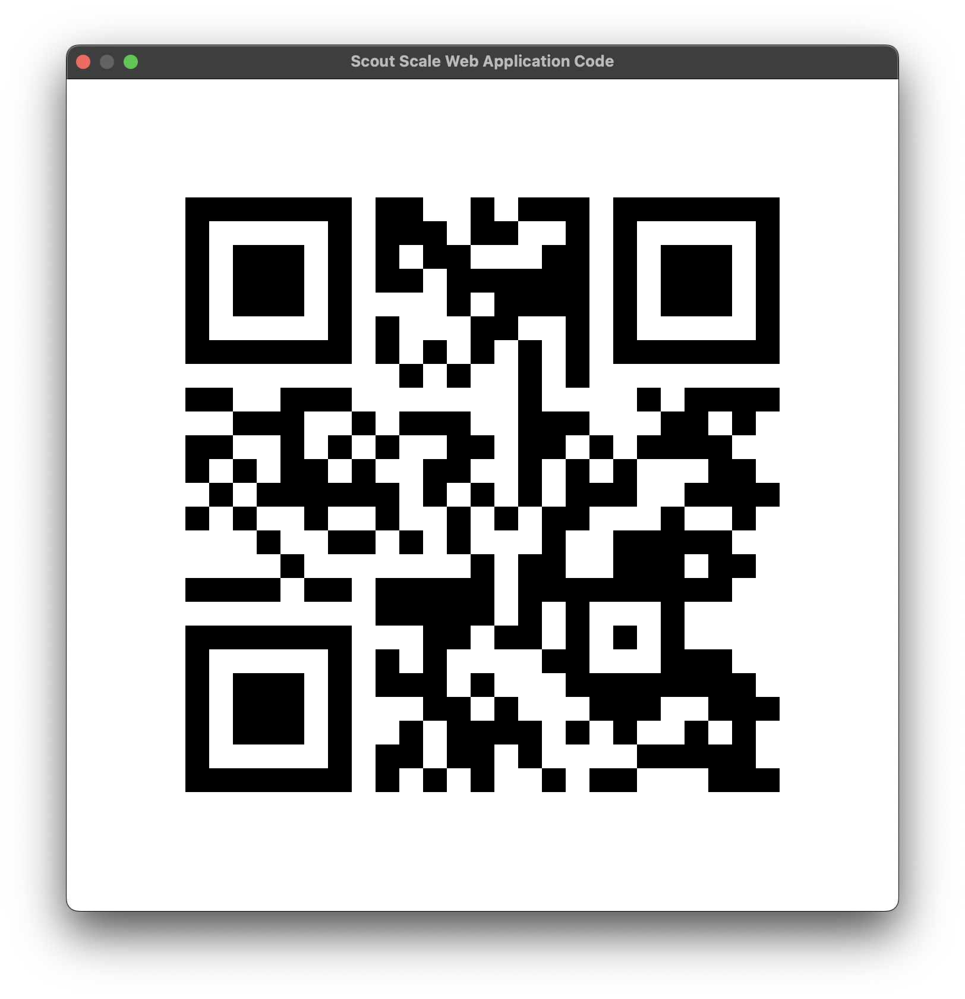

### Delete Previous Entry

Icon:  ⌫

Purpose:

The delete previous entry button allows the user to delete the previous entry. This allows for errant entries to be deleted from both the local .csv file and the database. It should be noted that only the most previous entry can be deleted. Entry deletion confirmation window shown below.

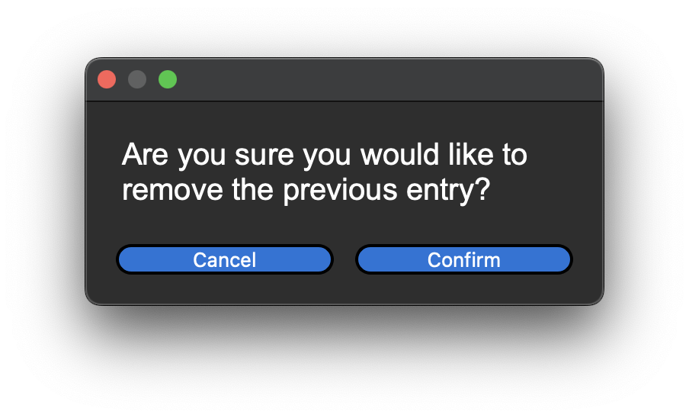

If the user wishes to delete multiple previous entries, they must do it directly on the database and .csv file.

### Debugging Mode

Icon:  🐞

Purpose:

Debugging mode allows the user to view the direct values reported by each load leg for the ScoutScale hardware. The debugging window is shown below.

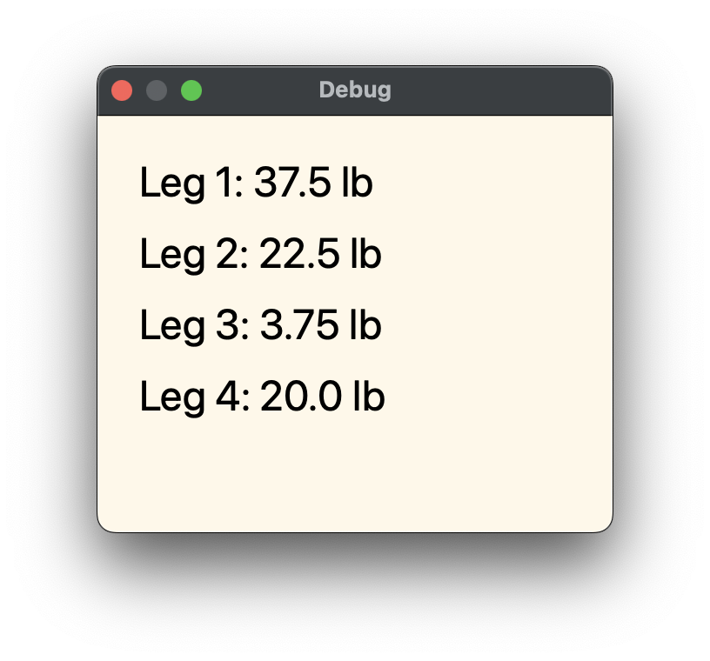

This window allows the user to troubleshoot issues with leg alignment and weight distribution. Abnormally low leg values, like that shown for Leg 3, can point to misalignment of load legs, leading to weight not being captured. Therefore, it is important to verify that all load legs are in an upright position and that all table weight is being placed on to the load cells. This debugging window helps diagnose these issues and confirm they have been resolved.

The other main feature of debugging mode is the use of a known weight to verify the accuracy of your captured weight value. As referred to in the settings section above, the user can enter a known weight value that will be used to verify the accuracy of a weight capture. Let us walk through this procedure, assuming that debugging mode is active.

Step 1: Load the table with all food you wish to capture.

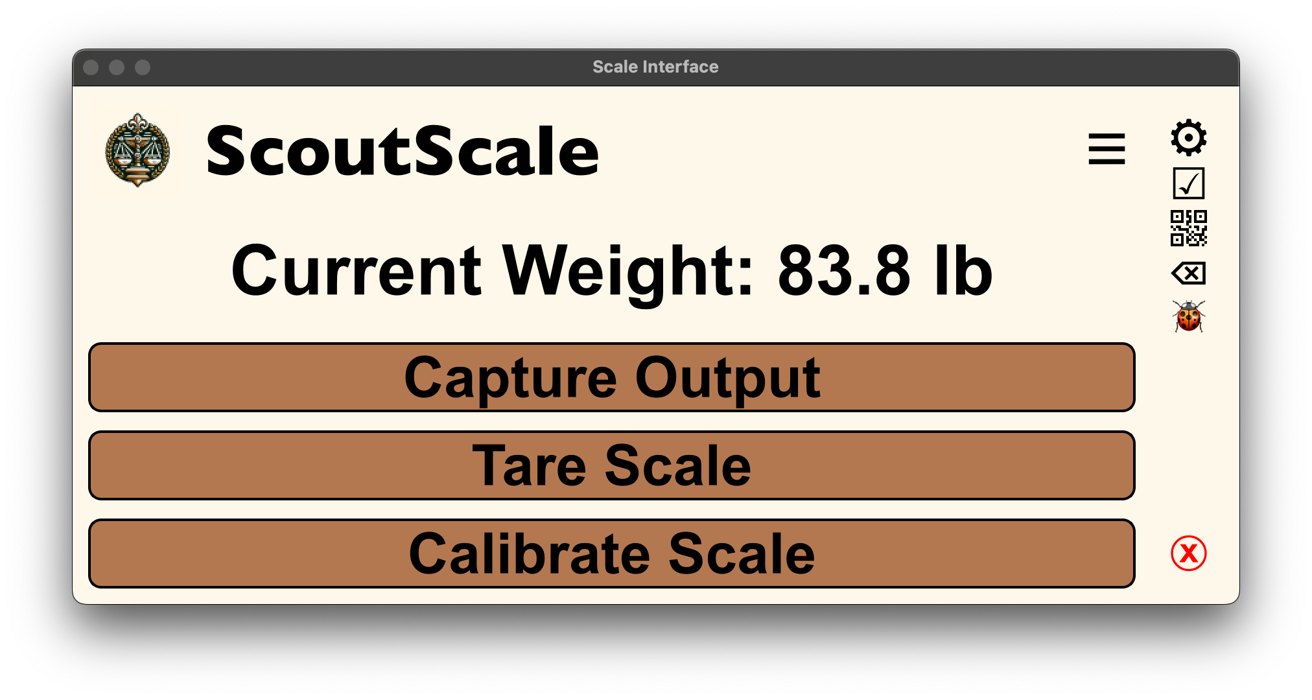

Step 2: Press the capture output button and view the capture window.

* Note that an additional field has been added to the capture view, named Expected Weight. This value is the captured weight plus the known weight entered in the settings window.

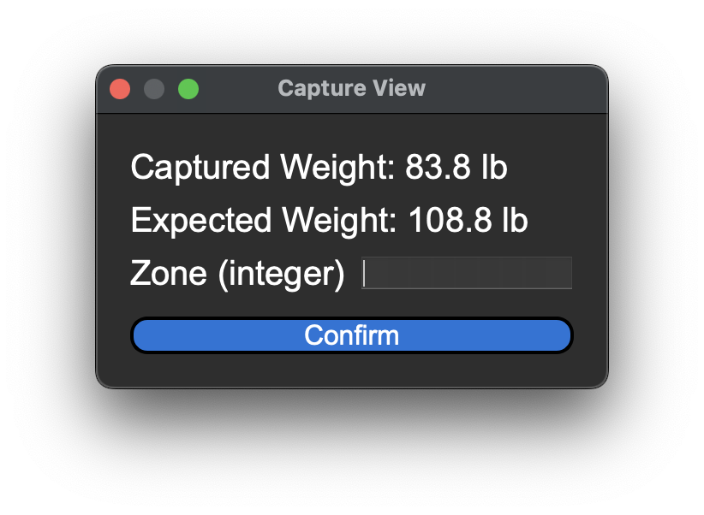

Step 3: Add the known weight to the table and verify that the Expected Weight matches the Current Weight displayed in the main window.

* In this case the known weight is set to 25 lbs., making the expected weight 25 lbs. more than the captured weight.
* As shown in the figure below, after the 25 lb. weight has been added to the table the current weight has been updated to match the expected weight.

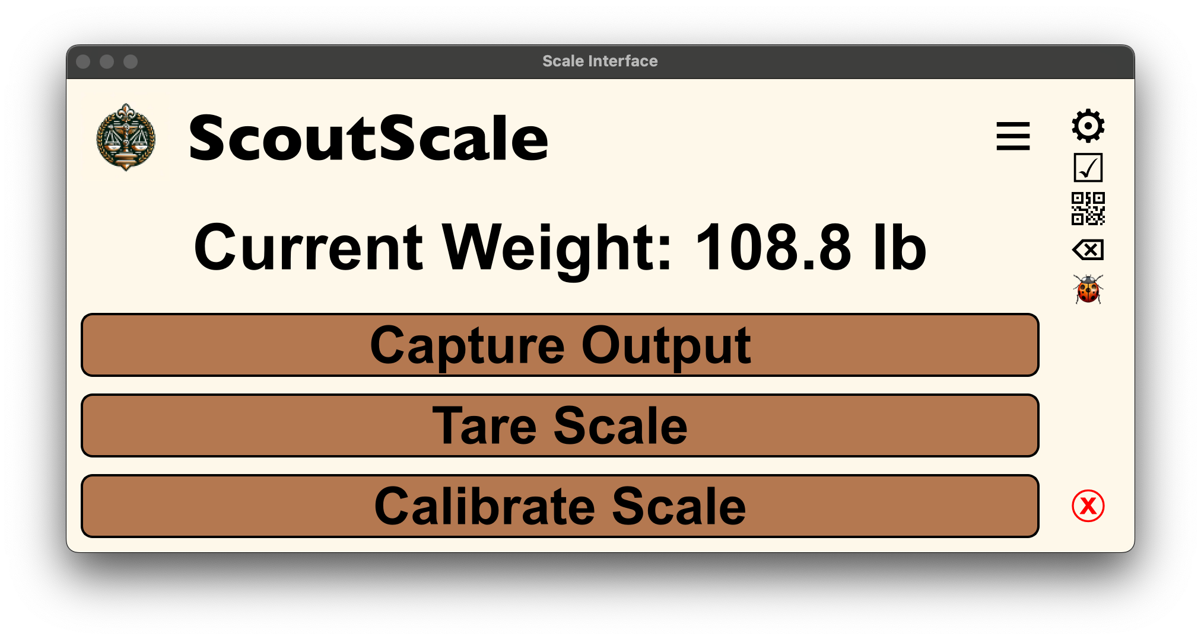

### Exit Program

Icon:  ⓧ

Purpose:

The exit program button allows the user to terminate the ScoutScale desktop application. It will open a confirmation window which, when confirmed, will exit the program.

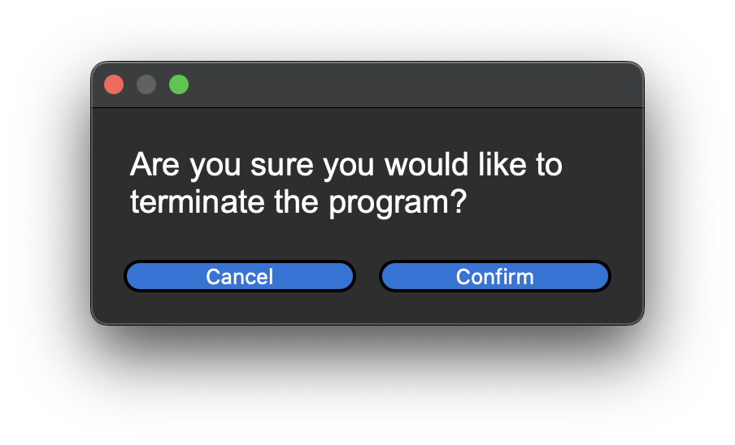

# Common Issues and Potential Solutions

## Arduino Board Not Functioning Correctly

PROBLEM:

The Arduino board is not supplying correct data values to the ScoutScale UI software or is not responding to communication from the ScoutScale UI software.

POTENTIAL SOLUTION:

There are two potential solutions to this issue, either a hardware reset of the Arduino board or a reupload of the ScoutScale Firmware Script.

HARDWARE RESET

INSERT PICTURE OF THE HUB BOX WITH BUTTON

To perform a hardware reset of the Arduino Board simply press the button on the side of the scale hub and wait around 10 seconds for it to take effect.

FIRMWARE REUPLOAD

To reupload the firmware script to the Arduino you must first install the Arduino IDE application, located here: <https://www.arduino.cc/en/software>. After installing the IDE, you need to download the scale_firmware.ino sketch from the ScoutScale GitHub Repository. Once you have acquired the firmware sketch and Arduino IDE open the sketch in the IDE. Your application should look similar to the view shown in the figure below.

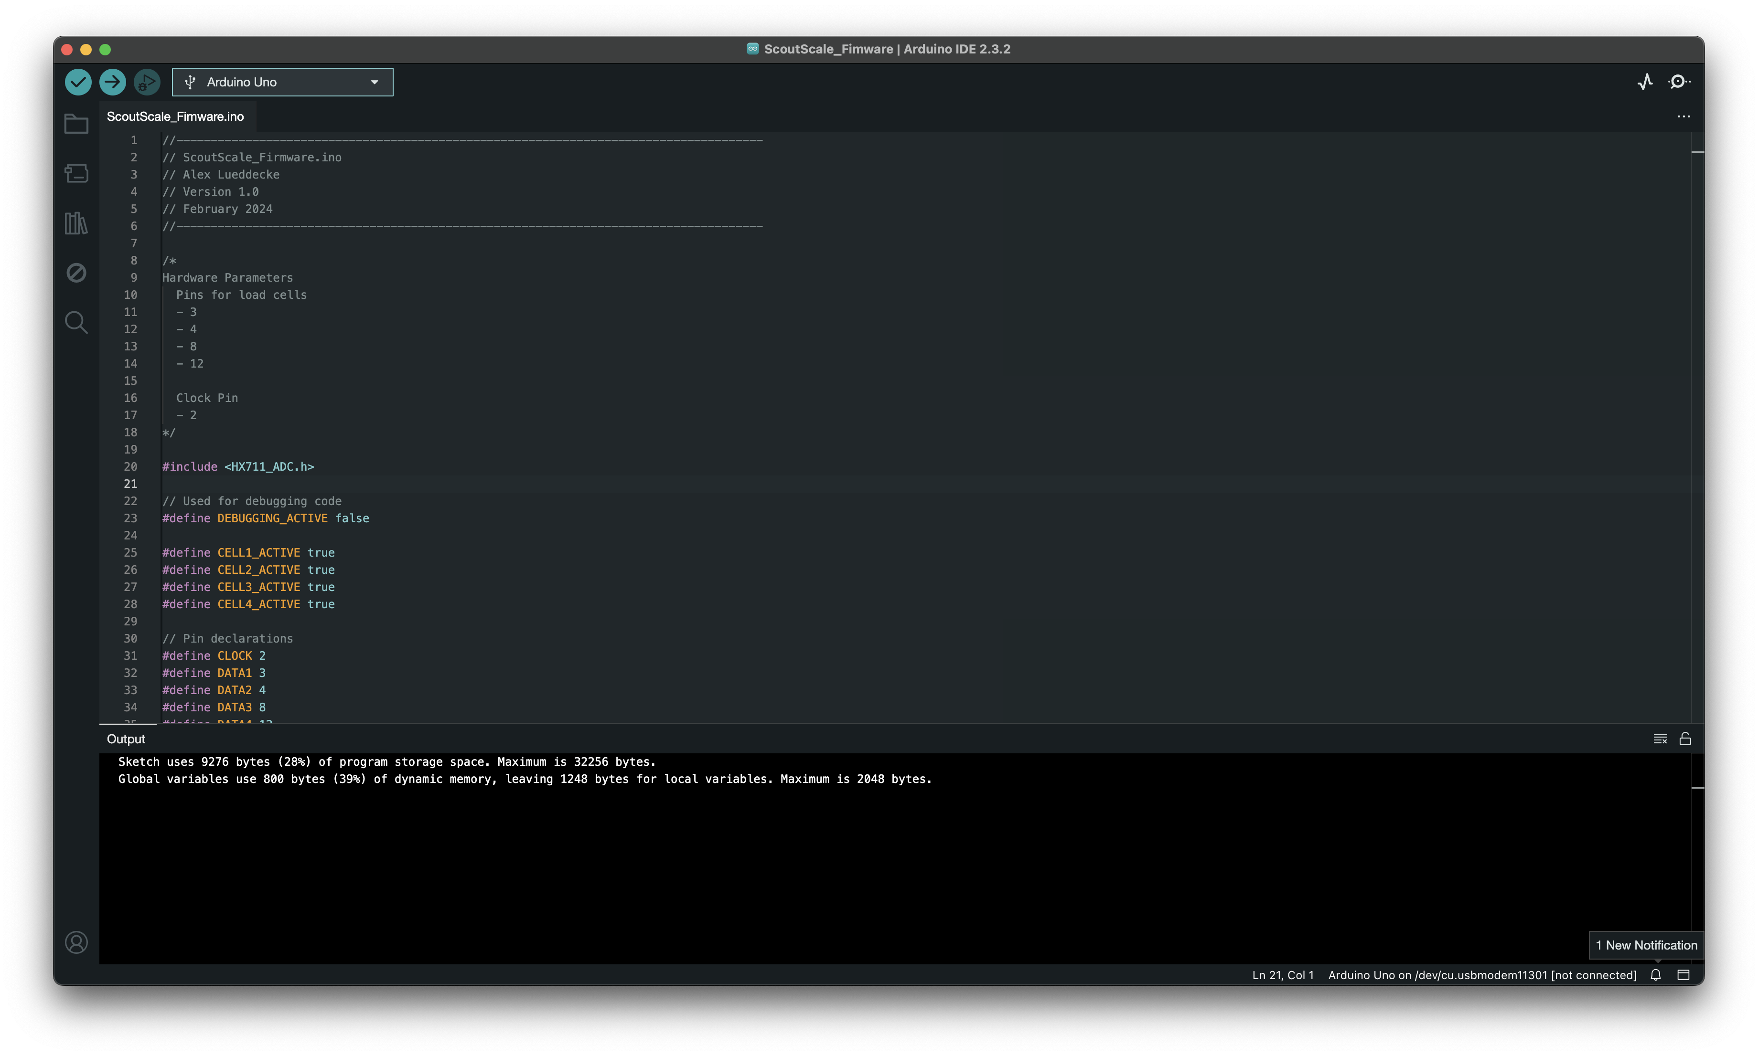After opening the sketch make sure to select the correct device from the device list located at the top left of the Arduino IDE application. If you are unsure which device is the Arduino board simply unplug the board, open the device list, and plug the board back in. This should allow you to see a new device be added to the list of serial devices and this will be the ScoutScale Arduino board. Once you have selected the correct board from the device list simply press the run button, noted by an arrow pointing to the right (à), and wait a few seconds for the script to compile and upload. You should see a message in the Output section of the Arduino IDE application that lets you know the upload was successful.

## Serial Errors When Attempting to Launch

PROBLEM

When attempting to launch __main__.py the console will output errors from a serial device.

POTENTIAL SOLUTION

Rerun setup.sh.

## Program Window too Large to View

PROBLEM

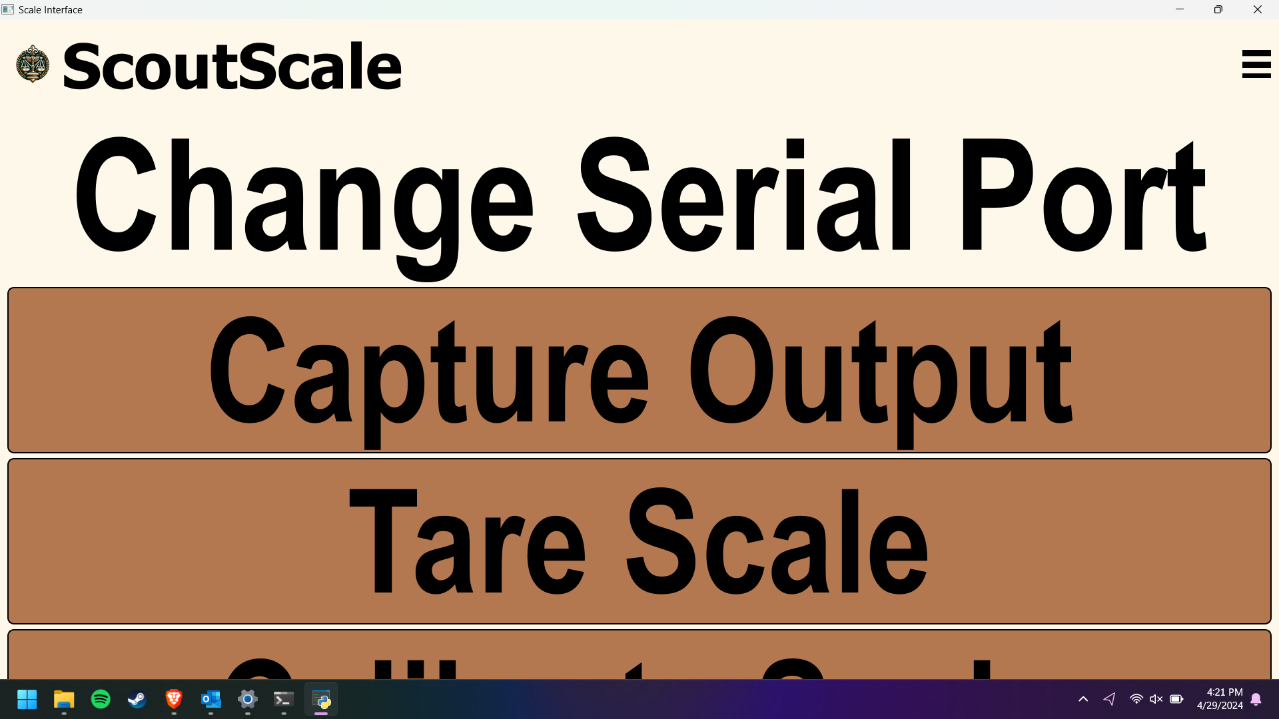

Program screen becomes too large to view when launching the program.

POTENTIAL SOLUTION

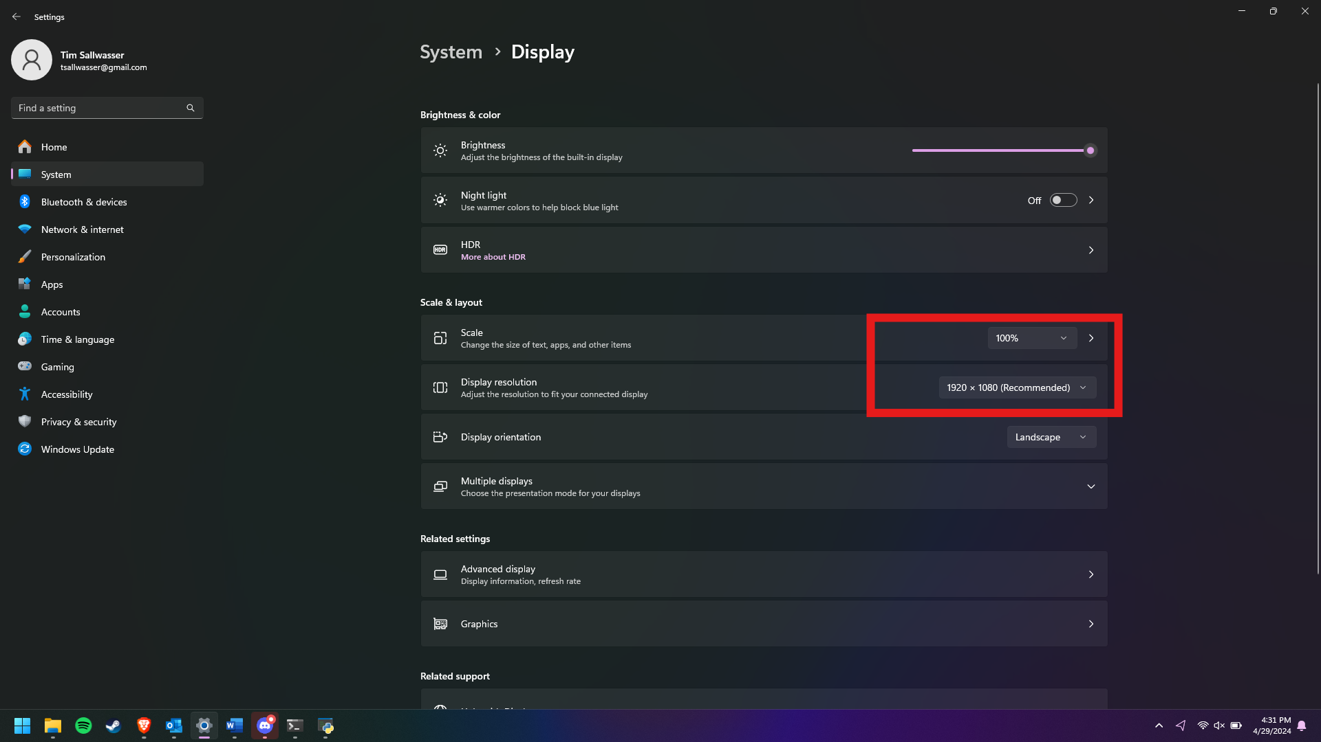

Ensure that laptop display is set to 100% scaling and using 1920X1080 resolution.